76.10.27
From William Woolls
RB MSS M46, Library, Royal Botanic Gardens Melbourne.

Richmond N.S.W.
Oct 27 /76
My dear Doctor,
I had a trip yesterday to "Cabbage Tree Hollow" at the Kurrajong. I found there Alsophila australis A. Leichhardti, & also Dicksonia Antarctica! But the tree which attracted my notice most was a palm looking tree of about 30 ft high, with slender stem, & leaved only at the summit. The leaves are pinnate, three feet long, with 18 or 19 pairs of leaflets. The scars or marks of former branches appear slightly along the trunk.
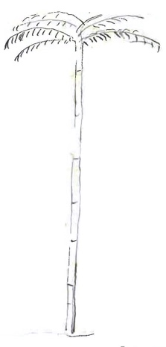
This is the appearance of the tree. It is very graceful & interesting associated with 3 three ferns, Howittia trilocilar, Passiflora Cinnabarina, Backhousia myrtifolia, Callicoma &c
I send you some leaves. Is the tree that which Sir W. Macarthur collected under the name of Botryodendrum? or is it your Araliaceous tree Panax Murrayi (Frag vol. 2/. 106). It is not at present in flower but I dare say my friend can watch it.
Will you kindly tell me, whether the introduced composite from cultivated fields is Tolpis?
Yours very Sincerely
W. Woolls

Alsophila australis
Alsophila Leichhardti
Backhousia myrtifolia
Botryodendrum
Callicoma
Dicksonia Antarctica
Howittia trilocilar
Panax Murrayi
Passiflora Cinnabarina
Tolpis

MS found with a specimen of Polyscias murrayi (MEL 2249418).
NSW.
Alsophila leichhardtiana?
The sketch is drawn to the left of this paragraph: 76-10-27_image01.jpg
Howittia trilocularis?

